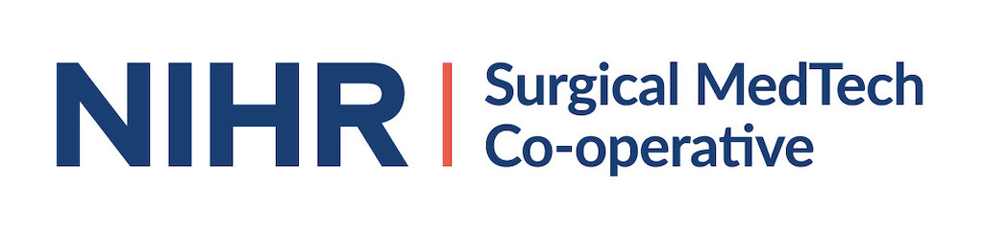
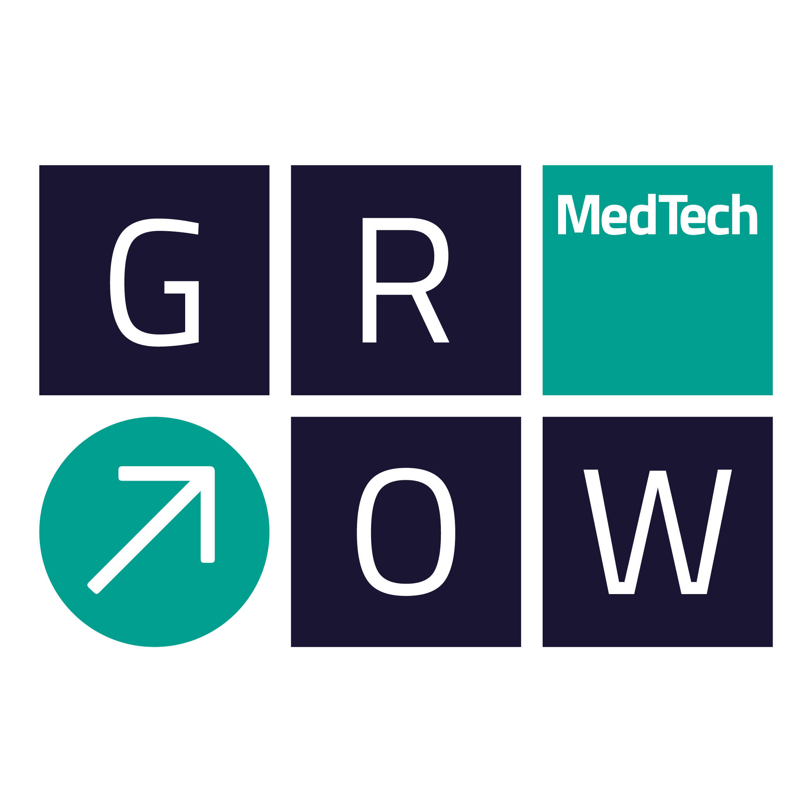

SURGICAL MEDTECH CO-OPERATIVE INCUBATOR PACKAGE

APPLICATION FORM

Title:
Lay Summary:
Project Lead:
Employing Organisation:
Contact details | E-mail: | Tel:
Collaborators (if any):
Academic Collaborators
Clinical Collaborators
Industrial Collaborators
Are any agreements in place between the Parties?
Additional details:
Innovation/Idea/Proposal
(200 words max)
Background work completed to date which underpins this project
(250 words max)
Business Opportunity
(200 words max)
Summary of Intellectual Property associated with the project (existing and/or anticipated to arise during the project)
(250 words max)
What competing research is there in this area / what products are there already on the market?
Why is what you propose superior?
(250 words max)
Deliverables:
Incubator Package Deliverables
(250 words max)
Duration
Plans for involving and engaging patients and members of the public (PPI)?
Plans for disseminating results
Next steps following completion
(150 words max)
Total costs
Justification of total costs
(150 words max)
Value for Money
Why should the project should be funded by this scheme and not another grant funding source?
(max 100 words)

Key Dates
- Deadline for applications | - 02 March 2020  - 06 April 2020  - 18 May 2020  - 02 July 2020  - 25 August 2020  - 06 October 2020  - 19 November 2020

How the NIHR deals with ownership of any Intellectual Property that may arise from any of the funded activities?
The position regarding Intellectual Property rights in these projects is the same as with regard to any other direct use of NIHR funding: -

- The award is subject to the terms of the Funding Agreement between Department of Health and Social Care and the host organisation of the Surgical MedTech Co-operative (The Leeds Teaching Hospital NHS Trust).

- The awardee, or any collaborator of the awardee, can own NIHR-funded IP subject to the provisions of those contracts (provisions are available by request).

- The owner of NIHR-funded IP can use it in further research, teaching, and for other non-commercial purposes.

- Any commercial use of NIHR-funded IP (e.g. direct sale, licensing IP to use in a product or service, use for marketing or in a regulatory application, etc.) requires the prior written consent of NIHR and may be subject to conditions imposed by NIHR (e.g. requirement to share revenue with NIHR, etc.).

- “NIHR-funded IP”, in this case refers to data and results, as well as ‘true’ IP such as patentable inventions and so on. It also applies to improvements to Background IP funded by NIHR. The terms apply where NIHR funding has only partly-funded the generation of the IP, but it is assumed that NIHR’s consent requirement on commercialisation will consider the fact that it didn’t fully-fund the project.

- NIHR also has various lesser rights to copyright in progress reports, to take control of IP if it is not being properly exploited, etc.

Stay informed about GrowMedTech:

Opt in to the mailing list: https://growmed.tech/contact/
Follow on Twitter: https://twitter.com/growmedtech
Follow on Linked In: https://www.linkedin.com/company/grow-medtech/

