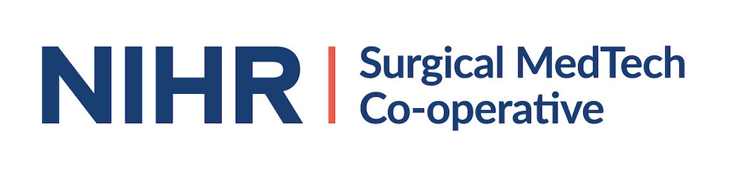
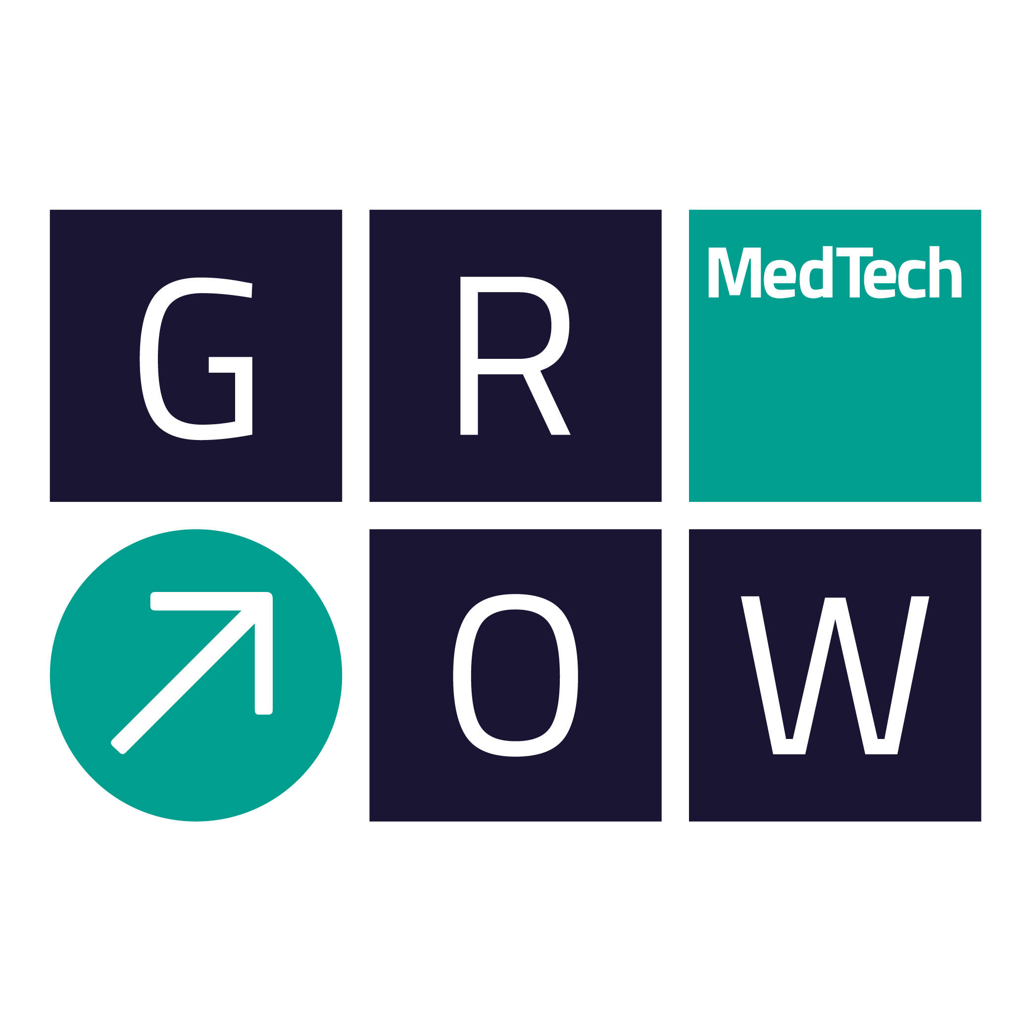

SURGICAL MEDTECH CO-OPERATIVE FUNDING COMPETITION 2020/21

APPLICATION FORM

Please indicate the funding call that you wish to apply for (please tick one only)
1a | Technology Driven Theme: Convergence of Technologies  (up to £10K funding)
1b | Clinically Driven Theme: The Future of Surgery  (up to £10K funding)
2 | Incubator Packages  (up to £5K funding)

Project title
Lay Summary
Project Lead
Organisation
Contact details | E-mail: | Tel:
Collaborators
Academic Collaborators
Clinical Collaborators
(mandatory)
Industrial Collaborators
Amount of match funding being provided by Industrial Partner
Are any agreements in place between the Parties?
Clinical Need, Business Opportunity and IP
Clinical Need
(200 words max)
Business Opportunity
(200 words max)
Summary of Intellectual Property associated with the project (existing and/or anticipated to arise during the project)
(250 words max)
What competing research is there in this area / what products are there already on the market?
Why is what you propose superior?
(250 words max)
The Project
Background work completed to date which underpins this project
(250 words max)
Project Aims
(250 words max)
Project Deliverables
(250 words max)
Project Duration
Plans for involving and engaging patients and members of the public (PPI)?
Plans for disseminating research and results
Next steps following completion of this project
(150 words max)
Total project costs
Justification of total project costs
(150 words max)
Project Work Packages
Please give details of what will be done in each of the project work packages, who in your team will be leading the work package, what role others in the team will play in the delivery of it, what the deliverables for each are, how long each one will take and where in the overall project it fits
(Add or delete tables as needed)
Work Package 1
Lead Partner:

Deliverables:

Work package tasks:

Human Resource requirements:

Consumable requirements:

Timescale:

Other partners and roles
Partner | Role

Work Package 2
Lead Partner:

Deliverables:

Work package tasks:

Human Resource requirements:

Consumable requirements:

Timescale:

Other partners and roles
Partner | Role

Work Package 3
Lead Partner:

Deliverables:

Work package tasks:

Human Resource requirements:

Consumable requirements:

Timescale:

Other partners and roles
Partner | Role

Work Package 4
Lead Partner:

Deliverables:

Work package tasks:

Human Resource requirements:

Consumable requirements:

Timescale:

Other partners and roles
Partner | Role

Project Risks
Please state the top 5 risks associated with this project, their likelihood (high, medium, low), their impact on the project (high, medium, low) and how that risk will be mitigated
Risk | Likelihood (H,M,L) | Impact (H,M,L) | Mitigation strategy

Other information
Why should the project should be funded by this scheme and not another grant funding source?
(max 100 words)
Publications:
Please list any relevant publications to your project
(max 10)

Key Dates
- Deadline for applications | - 02 March 2020  - 06 April 2020  - 18 May 2020  - 02 July 2020  - 25 August 2020  - 06 October 2020  - 19 November 2020

How the NIHR deals with ownership of any Intellectual Property that may arise from any of the funded activities?
The position regarding Intellectual Property rights in these projects is the same as with regard to any other direct use of NIHR funding: -

- The award is subject to the terms of the Funding Agreement between Department of Health and Social Care and the host organisation of the Surgical MedTech Co-operative (The Leeds Teaching Hospital NHS Trust).

- The awardee, or any collaborator of the awardee, can own NIHR-funded IP subject to the provisions of those contracts (provisions are available by request).

- The owner of NIHR-funded IP can use it in further research, teaching, and for other non-commercial purposes.

- Any commercial use of NIHR-funded IP (e.g. direct sale, licensing IP to use in a product or service, use for marketing or in a regulatory application, etc.) requires the prior written consent of NIHR and may be subject to conditions imposed by NIHR (e.g. requirement to share revenue with NIHR, etc.).

- “NIHR-funded IP”, in this case refers to data and results, as well as ‘true’ IP such as patentable inventions and so on. It also applies to improvements to Background IP funded by NIHR. The terms apply where NIHR funding has only partly-funded the generation of the IP, but it is assumed that NIHR’s consent requirement on commercialisation will consider the fact that it didn’t fully-fund the project.

- NIHR also has various lesser rights to copyright in progress reports, to take control of IP if it is not being properly exploited, etc.

Stay informed about GrowMedTech:

Opt in to the mailing list: https://growmed.tech/contact/
Follow on Twitter: https://twitter.com/growmedtech
Follow on Linked In: https://www.linkedin.com/company/grow-medtech/

