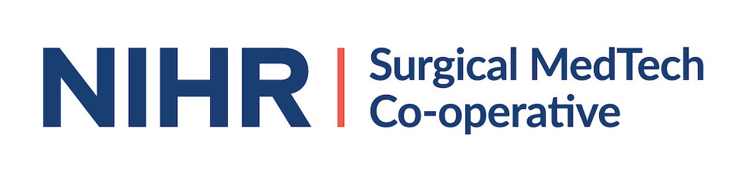
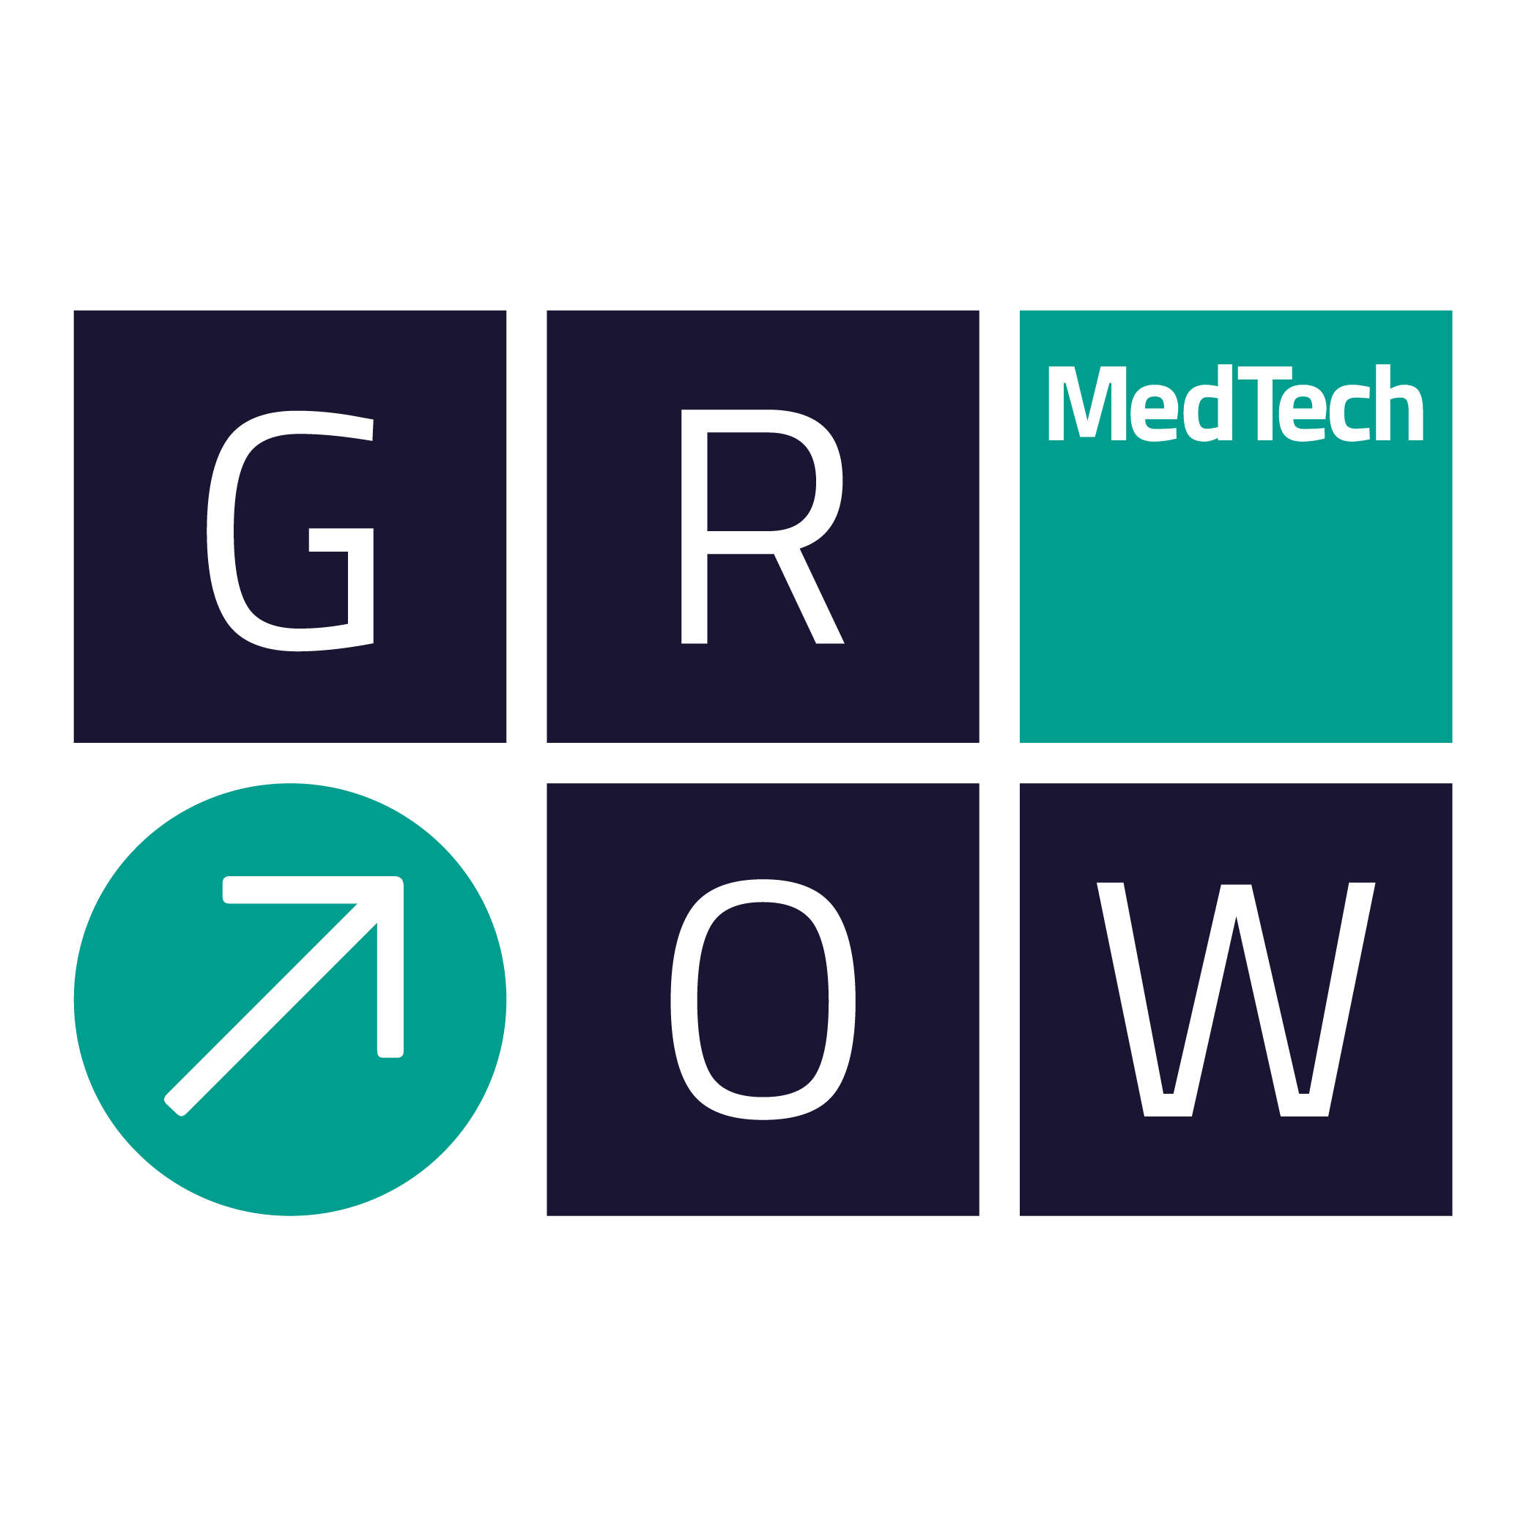

SURGICAL MEDTECH CO-OPERATIVE FUNDING COMPETITION 2019/20

APPLICATION FORM

Please indicate the funding call that you wish to apply for (please tick one only)
1a | Future Unmet Needs Call  Technology Driven Theme: Convergence of Technologies  (up to £10K funding)
1b | Future Unmet Needs Call  Clinically Driven Theme: The Future of Surgery  (up to £10K funding)
2 | Reactive Funding Calls - Incubator Packages for 2019/20  (up to £5K funding)

Project title
Lay Summary
Project Lead
Organisation
Contact details | E-mail: | Tel:
Collaborators
Academic Collaborators
Clinical Collaborators
(mandatory)
Industrial Collaborators
Amount of match funding being provided by Industrial Partner
Are any agreements in place between the Parties?
Clinical Need, Business Opportunity and IP
Clinical Need
(200 words max)
Business Opportunity
(200 words max)
Summary of Intellectual Property associated with the project (existing and/or anticipated to arise during the project)
(250 words max)
What competing research is there in this area / what products are there already on the market?
Why is what you propose superior?
(250 words max)
The Project
Background work completed to date which underpins this project
(250 words max)
Project Aims
(250 words max)
Project Deliverables
(250 words max)
Project Duration
Plans for involving and engaging patients and members of the public (PPI)?
Plans for disseminating research and results
Next steps following completion of this project
(150 words max)
Total project costs
Justification of total project costs
(150 words max)
Project Work Packages
Please give details of what will be done in each of the project work packages, who in your team will be leading the work package, what role others in the team will play in the delivery of it, what the deliverables for each are, how long each one will take and where in the overall project it fits
(Add or delete tables as needed)
Work Package 1
Lead Partner:

Deliverables:

Work package tasks:

Human Resource requirements:

Consumable requirements:

Timescale:

Other partners and roles
Partner | Role

Work Package 2
Lead Partner:

Deliverables:

Work package tasks:

Human Resource requirements:

Consumable requirements:

Timescale:

Other partners and roles
Partner | Role

Work Package 3
Lead Partner:

Deliverables:

Work package tasks:

Human Resource requirements:

Consumable requirements:

Timescale:

Other partners and roles
Partner | Role

Work Package 4
Lead Partner:

Deliverables:

Work package tasks:

Human Resource requirements:

Consumable requirements:

Timescale:

Other partners and roles
Partner | Role

Project Risks
Please state the top 5 risks associated with this project, their likelihood (high, medium, low), their impact on the project (high, medium, low) and how that risk will be mitigated
Risk | Likelihood (H,M,L) | Impact (H,M,L) | Mitigation strategy

Other information
Why should the project should be funded by this scheme and not another grant funding source?
(max 100 words)
Publications:
Please list any relevant publications to your project
(max 10)

Key Dates
- Future Unmet Needs Call for 2019/20  1a. Technology Driven Theme: Convergence of Technologies  1b. Clinically Driven Theme: The Future of Surgery | Call opens Monday 11th March 2019  Call Closes midnight Tuesday 30th April 2019
- Reactive Funding Calls - Incubator Packages for 2019/20 | Applications for Incubator Packages will be reviewed on the following dates – applicants are advised to submit their form at least one week before the meeting.  - 23 May 2019  - 04 July 2019  - 10 September 2019  - 24 October 2019  - 05 December 2019

Stay informed about GrowMedTech:

Opt in to the mailing list: https://growmed.tech/contact/
Follow on Twitter: https://twitter.com/growmedtech
Follow on Linked In: https://www.linkedin.com/company/grow-medtech/

